

MAJOK ALI
BSCCS/2024/35996
Bsc COMPUTER SCIENCE
BIT 3208
ADVANCED WEB DESIGN AND DEVELOPMENT
MR. NYORO
SEM 2/2026

Contents
WEEK 1 3
INSTALLATION AND TESTING OF LOCAL DEVELOPMENT ENVIRONMENT 3
FIG 2 3
WEEK 2 4
Fig : 1 Hand-Written Wireframe 4
Fig: 2 Product Wireframe 5
5
Fig :3 6
Week 3: JavaScript and PHP Basics 7
Password Strength Checker 7
Dynamic User Input Handling 7

  - WEEK 1
  - INSTALLATION AND TESTING OF LOCAL DEVELOPMENT ENVIRONMENT
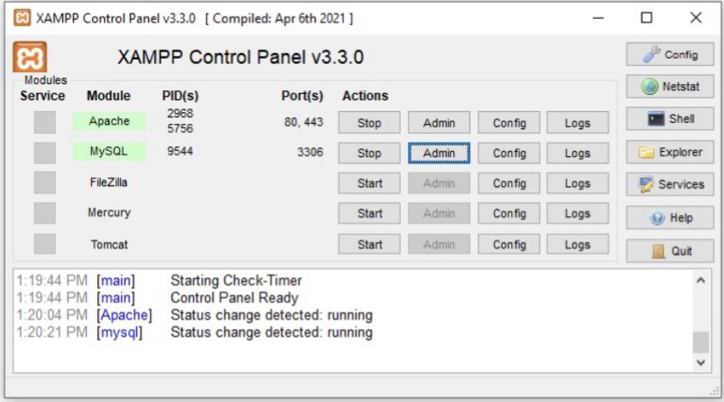
Fig:1

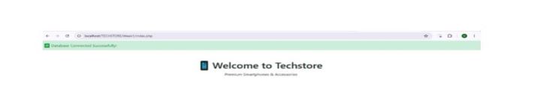

FIG 2: Shows successful connection between PHP and MYSQL. This confirmed that Apache and MYSQL were properly configured in Xampp

In Week 1, I successfully installed and configured XAMPP for local web development. I created the PhoneHub e-commerce project structure focused on selling smartphones and accessories. The PHP script db_connect.php successfully connected to MySQL database phonehub_week1. This setup forms the foundation for building a full dynamic e-commerce platform. The project is already under Git version control for professional workflow.

WEEK 2
Fig : 1 Hand-Written Wireframe
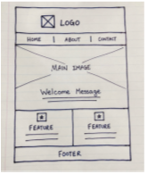

Fig: 2 Product Wireframe

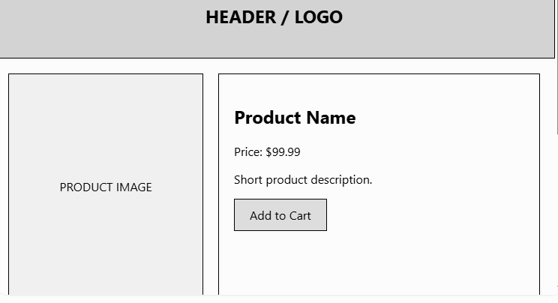

Fig :3
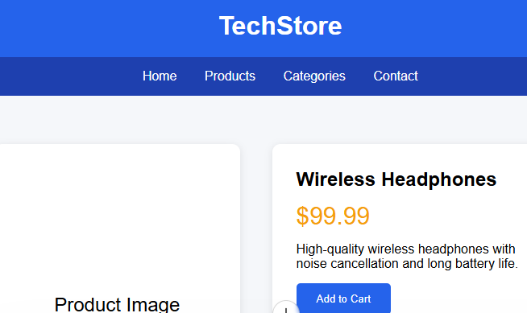

In Week 2 ,I designed a modern ,clean ,and responsive UI for PhoneHub E-commerce
The color scheme (Blue + orange) was chosen to convoy trust and energy suitable for Kenyan tech store. I created wireframes for all major pages and built a live HTML prototype for home page . This ensures excellent user Experience with easy navigation and mobile responsiveness .The design supports futures like cart and authentication .

Week 3: JavaScript and PHP Basics

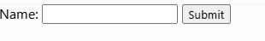
Fig :1

Password Strength Checker

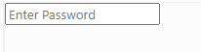
Fig:2

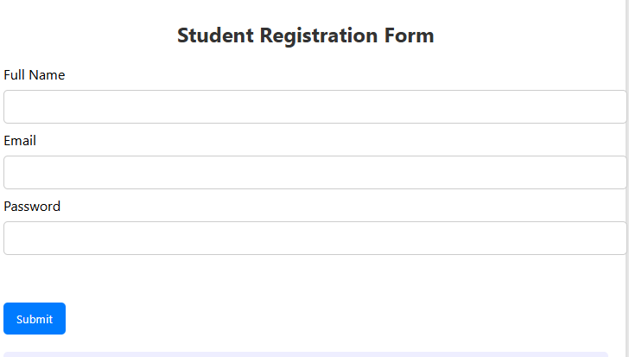
Fig :3
In Week 3 , I did this project helped me understand how JavaScript can be used to improve user interaction on a website. I learned how to validate form inputs, create a password strength checker, and dynamically display user-entered information without refreshing the page. Form validation ensures that users provide required information, while the password checker promotes stronger passwords. Dynamic input handling allows webpage content to update instantly based on user actions. Overall, this project enhanced my understanding of client-side scripting and demonstrated how JavaScript can be used to create interactive

